

**Mathematics Specialist**

**Test 5 2017**

**Rates of Change and Differential Equations**

**NAME: _______________________________________________ TEACHER: Mrs Da Cruz**

**Resource Free Section**

**29 marks**

**29 minutes**

1 What is  for $y^{3}-8x^{3}=6x^{2}$? (Fully simplify and factorize your answer.) [2 marks]

2 $y=x^{3}-5x^{2}-1$ and . Find  at x = 2. [2 mark]

3 What is the general solution to  = ? [1 mark]

4 Find the general solution of  = −6y. [1 mark]

5 Solve  = (1 − 2t)(y + 3) if y = $-$ 2 when t = 4. [3 mark]

6 Find the gradient of  at (x, y) and hence find the equation of the tangent through the point (−3, 3.2). [3 marks]

7 Water is being pumped through a pipe of diameter 15 cm at a rate of 2 L s−1. Find the exact speed at which the water travels through the pipe? [4 marks]

8 Solve $y^{'}{\left(y+1\right)}^{2}=\frac{1}{x^{2}}$.

[4 marks]

9 The diagram below shows the slope field of a differential equation $\frac{dy}{dx}=f(x,y)$.

[9 marks: 2, 2, 1, 2, 2]

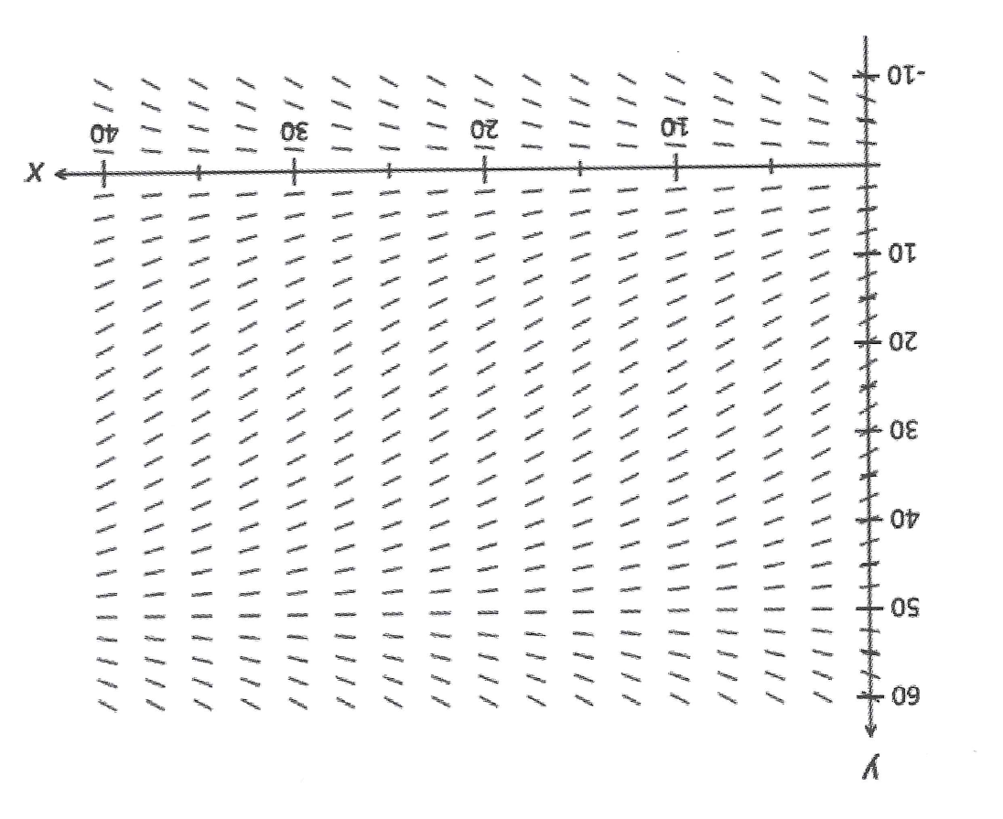

1. On the slope field given above, draw in the curve representing the particular solution with initial condition $\left(15,40\right).$
2. Mark and state the coordinates of the point on this particular solution curve where the gradient is steepest.
3. The differential equation corresponding to this slope field is actually independent of one of the variables $x$ or $y$.
4. Is that variable $x$ or $y$?
5. Explain how you know this?
6. Determine, with detailed, concise reasoning, if there is an isocline for *points on the slope field with gradients of 3*.



**Mathematics Specialist**

**Test 5 2017**

**Rates of Change and Differential Equations**

**NAME: _______________________________________________ TEACHER: Mrs Da Cruz**

**Resource Rich Section**

**16 marks**

**16 minutes**

**One unfolded A4 page of notes, SCSA formulae booklet and ClassPad calculator permitted**

9 One Newton is the force needed to accelerate 1kg of mass at 1 $m/s^{2}$. Force = mass x acceleration.

The force acting on an object of mass 8 kg is given by F = 4t + 1 newtons. The object is initially at rest. Find the speed and displacement of the object after 10 s. [6 marks]

10 Tasmanian Devils released on Maria Island increased in population from 24 to 30 in one year. It is thought that the maximum sustainable population on Maria Island is about 200 devils, but the number is to be limited to about 150.

Use a logistical model to find how long it will be before culling is needed if no more devils are released.

[7 marks]

11 The variables $t$ and $Q$ are related by the equation $Q=\sqrt{\frac{4π}{t}}.$ Use calculus to find the approximate change in $Q$ when $t$ is increased from 4 to 4.01. (Give answer to 3 sig. figs.) [3 marks]